The Natural Path, Ltd.
New Client Information Form
Please print clearly Page 1 of 6

General Information

Name_______________________________________ Date__________________
Address________________________________________ Apt.#__________________ City_____________________________ State____________ ZIP________________
Email________________________________
Would you like to receive an email copy of our monthly newsletter? Yes [ ] No [ ]

Shipping Address (if different from above) Address________________________________________ Apt.#__________________ City_____________________________ State____________ ZIP________________

Home Phone (_____) ______-________ Work/Cell Phone (_____) ______-________
Contact preference: Text [ ] Call [ ]
Referred By _____________________________________________

Occupation _________________________ Employer ___________________________

DOB________________________ Age _____ Sex: M/F Height _____Weight _____

Marital Status: S M D W Name of Spouse _________________
Number of children (if any): _________

Overall Health (circle one): Excellent / Good / Fair / Poor / Other: _________________
Health of Spouse (if applicable): Excellent / Good / Fair / Poor / Other: _____________

Emergency Contact
Name _____________________________________ Phone______________________

Allergies to Medication (list medication & type of reaction): ______________________________________________________________________
Allergies to Food (list food & type of reaction):
______________________________________________________________________
Chief complaint (reason you are here): _______________________________________ ______________________________________________________________________

Signature:__________________________________________ Date: ______________

The Natural Path, Ltd.
Authorizations
Page 2 of 6

Authorization for the use of Complementary and Alternative Care

I have been advised that The Natural Path, Ltd. (2212 S. College, Ave, Ft. Collins, CO 80525, 970-829-1110) offers complementary and alternative health care services pursuant to "Colorado Natural Health Consumer Protection Act" SB13-215. As such, they are not licensed, certified, or registered by the state as health care professionals. The Natural Path, Ltd. is not affiliated with any Naturopathic Doctors nor practices any form of Naturopathic Medicine.

I may be provided any of the following services: Neuro Emotional Technique (NET®), Nutritional Kinesiology (muscle testing), Biofeedback, Body Work Therapies, and Diet and Lifestyle Recommendations. Carl Malone’s credentials to provide these services include the following:

- American Naturopathic Medical Certification Board – Board Certified Doctor of Natural Medicine (#06724)
- Doctor of Natural Medicine (IBEM 2013)
- Doctor of BioEnergetic Medicine (IBEM 2013)
- Doctor of Sacred Medicine (IBEM 2013)
- Certified Biofeedback Practitioner (IBEM 2012)
- Psychotherapist (#NLC.0108586)
- Colorado Registered Massage Therapist (#MT0009541)
- Craniosacral Therapy - (Upledger Institute 2004)
- Brimhall Certified Practitioner (2011)
- Nutrition Response Testing (2014)
- Neuro Emotional Technique (2016)
- Muscle Response Analysis (2016)
- Contact Reflex Analysis (2018)
- SHAPE ReClaimed Certified Practitioner (2021)
- Founder of LaserNMT training for Practitioners

In addition to formal credentials, Carl Malone has attended numerous seminars and hours of training in health, nutrition and body therapies, with a particular focus on low-level laser therapy.
The information and services provided to me are not intended to be a substitute for obtaining professional medical advice, diagnosis, or treatment. The Natural Path, Ltd. is not a licensed medical entity, is not affiliated with insurance entities, and does not practice medicine, or render medical advice. I am encouraged to always discuss recommendations made by any complementary and alternative health care provider with my primary care physician.

Client (printed name): ________________________________
Signature: _________________________________ Date: ____________
The Natural Path, Ltd.
Authorizations
Page 3 of 6

Authorization for the use of Neuro Emotional Technique (NET®)

The information provided by and to the client during therapy sessions is legally confidential and cannot be released without the client’s consent.

Client (printed name): ________________________________
Signature: _______________________________ Date: ____________

Authorization for the use of Nutritional Kinesiology

I specifically authorize the natural health practitioners at The Natural Path, Ltd. to perform a non-invasive health analysis using Nutritional Kinesiology. The purpose of this exam is to develop a natural health improvement program for me, which may include dietary modifications, nutritional supplementation, natural body and system cleanses, as well as ongoing education. The purpose of which is to improve my overall health, and not for the purpose of treatment or “cure” of any known or unknown disease.
I understand that Nutritional Kinesiology is a safe, non-invasive, natural approach for analyzing the body's physical and nutritional needs as well as identify possible deficiencies or imbalances in areas that could cause or contribute to my various health concerns.
I understand that Nutritional Kinesiology is not a method for diagnosing or treating any known or unknown disease including conditions such as cancer, diabetes, heart disease, infections or other medical conditions and that these are not being tested for or treated.
No promise or guarantee has been made regarding the results of Nutritional Kinesiology or any natural health, nutritional or dietary program recommended. I understand that Nutritional Kinesiology is a means by which the body's natural reflexes can be used to aid in determining possible nutritional imbalances, so that a safe natural program can be developed for the purpose of bringing about a more optimal state of health.
Client (printed name): ________________________________
Signature: _______________________________ Date: ____________

The Natural Path, Ltd.
Authorizations
Page 4 of 6

Authorization for the use of Body Therapy and Cold Laser Therapy

I, the undersigned client, hereby authorize The Natural Path, Ltd. appointed staff to administer such therapy as is necessary. I hereby certify that I understand the advantages and possible complications. I also certify that no guarantee or assurance has been made as to the results that may be obtained.

Client (printed name): ________________________________

Signature: _______________________________ Date: ____________

Regarding Your Pharmaceutical Medications:

At The Natural Path, Ltd., we DO NOT prescribe or “un-prescribe” any pharmaceutical medications. All dosing of your prescription medications must be done through the doctor who prescribed them for you.
Client (printed name): ________________________________

Signature: _______________________________ Date: ____________

Regarding Insurance Claims:
This office is NOT an approved direct provider to insurance companies. As such, we do not provide a Medical Necessity letter to any insurance companies for reimbursement of services or products.
We will provide you with a copy of your file, if needed for reimbursement, for a $5.00 documentation preparation fee. A copy of your receipt in payment for product and services will be provided to you following each of your visits.
Client (printed name): ________________________________
Signature: _______________________________ Date: ____________

All above authorizations need to be signed and dated, indicating that you have read and understand each. If a minor, the signature of a parent or guardian is required. These signed authorizations apply to subsequent visits and consultations provided either in person or remotely.
The Natural Path, Ltd.

Office Policies
Page 5 of 6

Payments
- Payment is due at time of service. We do not bill insurance.

- We accept cash, check or debit/credit. We prefer cash or check and may have to charge a credit card fee for large purchases.
Initial _________
Refunds
- Refunds are not provided for services already rendered.

- Products may be returned for refund if unopened and undamaged within 30 days of purchase. Credit card fees are not refunded.
Initial _________
Appointments
- Appointments may be cancelled or rescheduled with at least 24 hour notice.

- More than 2 late cancellations (less than 24 hour notice) are subject to all future appointments being prepaid or loss of a session if already prepaid.

- If more than 10 minutes late, the appointment may need to be rescheduled. Please understand that your appointment may be shortened if you are running behind.

- ‘No Show/No Call’ appointments are subject to charge or loss of a session if session has been prepaid, as well as future appointments being prepaid.

Initial _________

We do our best to accommodate everyone’s scheduling needs. However, if you are unsure if you can commit to an appointment time, please consider calling on short-notice to see if there is availability rather than scheduling in advance. Cancellations, late arrivals and ‘No Show/No Calls’ may result in someone else not receiving the care they need at that time.

Printed Name:_________________________ Date:______________

Signature:_____________________________

Page 6 of 6
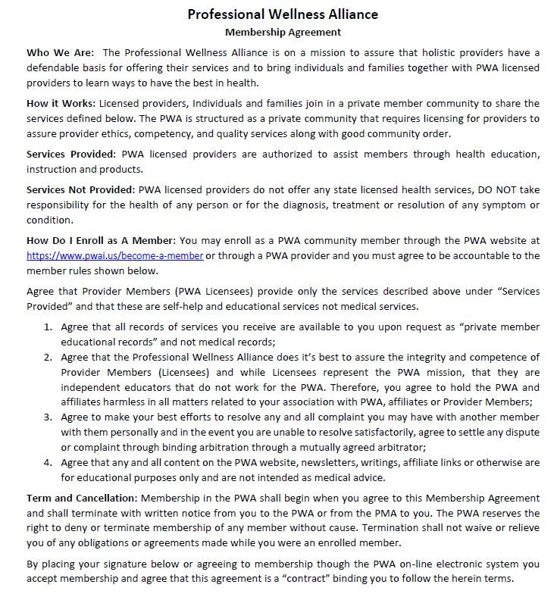
_________________________ ______________ ___________________________
Member Name Date Address

_____________________________ ________________ _______________________________
City / State / Zip Email Member Signature

Enrolled Into Membership By: ______MALONE_______ PWA Provider #______2450____________

Professional Wellness Alliance Member Agreement 2020

