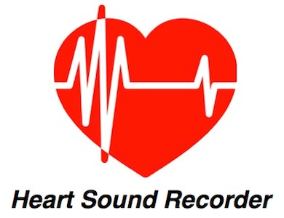
The Natural Path, Ltd.
2212 S. College Ave.
Fort Collins, CO 80525

970-829-1110 TheNaturalPathInfo@gmail.com

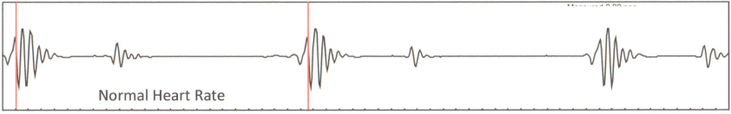
Ideal Heart Graph

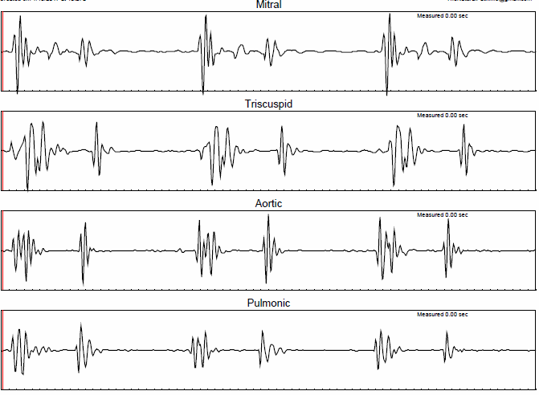
John Sample Results for 1/22/2017

Your Heart Sound Recorder results indicate there is a potential to fine-tune the functioning of your heart and thereby improve your overall health and wellbeing.

www.TheNaturalPathLtd.com/heart-scan.html

